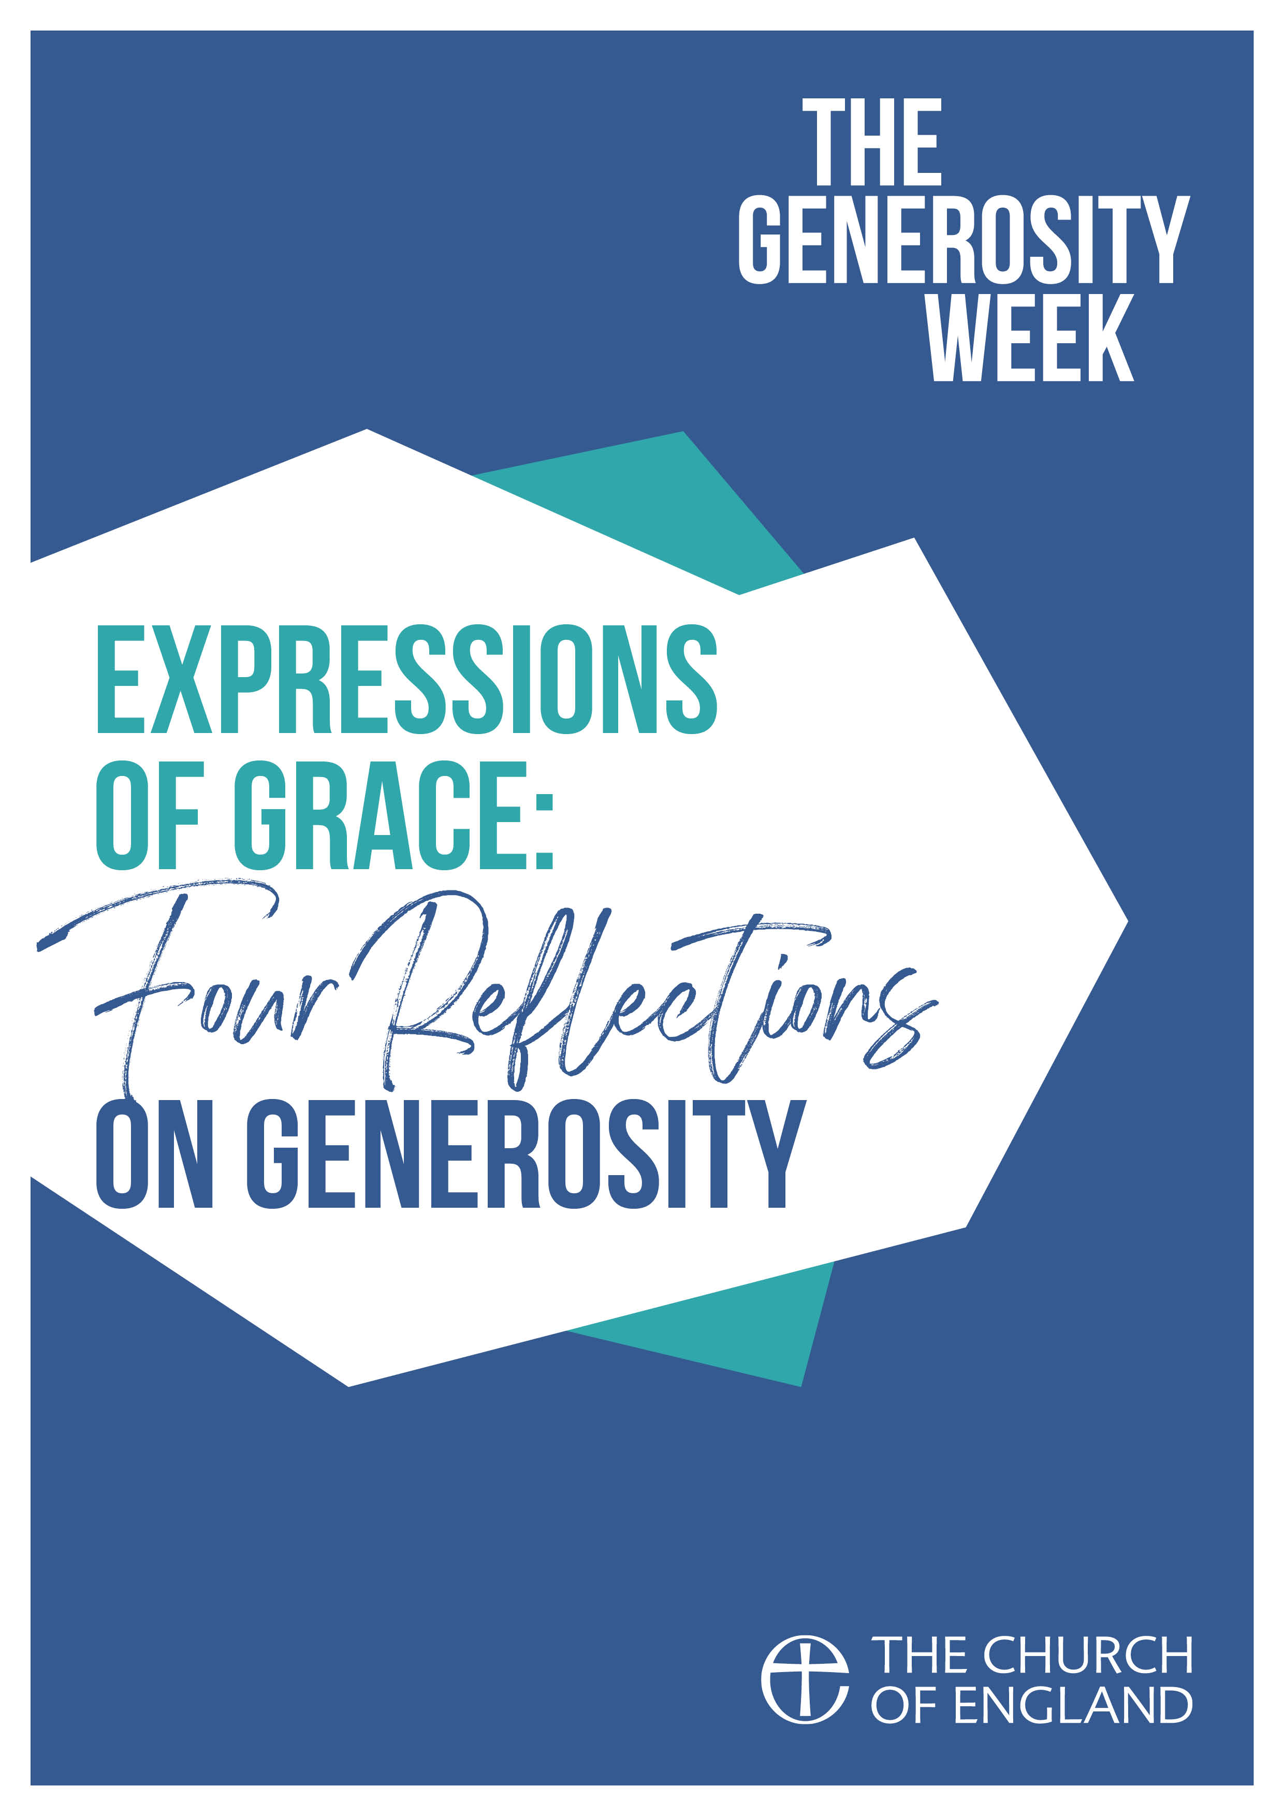

CONTENTS

INTRODUCTION Page 3

USING THIS GUIDE Page 4

OPENING PRAYERS Page 5

CLOSING PRAYERS Page 6

SESSION ONE Page 7
The Generosity of God

SESSION TWO Page 10
Grace, Gratitude and Gift

INTRODUCTION

Giving and generosity are inextricably linked with living out the Christian faith. Giving at its core is in the nature of God – and we see this weaved throughout the Bible in many guises. Generosity is not just about giving financially, although that does form a part of generosity when exploring stewardship and material possessions. The link between living out the Christian faith means exploring what it means to live a generous life – though hospitality, time, attentiveness, and many other attributes. It’s about our state of heart, and the relationship we have between material and spiritual things.

At its core, giving is a matter of discipleship, and at its best is an act of worship. And so when it comes to our thinking around generosity, we must centre our reflections around our calling as disciples, to follow in Jesus’ footsteps and grow together to become the Church he calls us to be.

In order to think about our own generosity, we must begin by reflecting on the generous nature of God, and how we respond to that with gratitude and grace. Our giving, in its broadest sense, then contributes to enabling God’s mission, and reveals the generosity and glory of God in the communities in which we are set. As we learn to give freely and with grace, we then grow as disciples and in Christ-likeness.

Despite this, giving and generosity is something we find challenging to talk about in our churches. We have inherited a culture where we tend to approach the subject only when we reach financial difficulties, and often cautiously or even apologetically. Our habit when thinking about giving is regularly done through a transactional lens, and it’s often easy to forget to explore the joy, mission and expression of grace which the outpouring of generosity enables.

We are invited to embrace the joy of a culture of generosity, grounded on a response to God’s generosity to us. Alike to anything of this nature, it will take time, prayer, and a commitment to shift our way of thinking.

One way to help embed a culture of generosity in our churches is through small groups or homegroups, which are ideal contexts to discuss and articulate particular topics, and pray and grow together towards lasting change. This guide attempts to explore some of the basic themes of Christian generosity – beginning with the generous nature of God, moving to looking at the notion of giving as gift, then to what is means to give sacrificially, and finally exploring our place within the body of Christ. We hope that together your group will use the material to teach, encourage and pray for one another to help in growing a culture of generosity, both personally and within your church communities.
Sammi Tooze
September 2020

USING THIS GUIDE

This collection of small group reflections are linked to the wider resource ‘The Generosity Week’, published by the National Giving Team 2020. Each session relates by theme to two podcasts and Morning Prayer services, and includes a short reflection followed by a series questions. You may wish to use these additional resources with your small group to add to the content in the sessions. There are suggested opening and closing prayers that can be used in every session if appropriate.

OPENING PRAYERS
Let everything be said and done in the name of the Lord Jesus,
giving thanks to God through Jesus Christ.
Let us bring our gifts to the Lord
that they may be used for his glory.
May the Spirit of God fill our hearts
as we come to meet him in this place.

Silence is kept.

Jesus said, “Do not store up for yourselves treasures on earth, where moth and rust consume and where thieves break in and steal; but store up for yourselves treasures in heaven, where neither moth nor rust consumes and where thieves do not break in and steal. For where your treasure is, there your heart will be also.”
Matthew 6.19-21

Loving God,
through the expression of grace
your Son came not to be served but to serve.
Nurture in us generous hearts,
that, in word and action,
your glory may be revealed;
in Jesus Christ our Lord.
Amen.
CLOSING PRAYERS
Come, you that are blessed;
as you serve these who are members of my family, you serve the Lord our God.
from Matthew 25.34-40

Silence is kept.

Blessed are you, Sovereign God,
our Rock and our salvation;
to you be glory and praise for ever.
You walk with your pilgrim people:
make us to know your ways and teach us your paths.
You sow in our lives the joy that comes from sharing,
and teach us that the gift grows with giving.
You breathe in us gracious hearts,
and reveal to us the delight of outpouring generosity,
so that in your presence we sing;
Blessed be God, Father, Son and Holy Spirit.
Blessed be God for ever.

Generous God,
send us out in the power of your Spirit
to live and work to your praise and glory.
Amen.

Let us bless the Lord.
Thanks be to God.

- The Generosity of God

“He determines the number of the stars; he gives to all of them their names.”
Psalm 147.4

A few years ago, I was fortunate to have the opportunity to visit Iona. On the first night, my friends and I decided to go for a walk after dinner. In a place where there are no street lamps, the darkness engulfed so peacefully, and because there is no light pollution the stars shone down so clearly – to me it looked almost like a painting. This was a beautiful moment witnessing God’s creation in all its beauty and creativity.

At the beginning of the Bible, we read the creation narrative as the first generous gift of God. From then on, it’s possible to read the entire Bible as a narrative of generosity, and the verse from Psalm 147 highlights some key aspects of the generous nature of God. In creation, God has called all things into being – in intricacy, in complexity and in beauty. He determines the number of the stars, the hairs on our head, and the grains of sand. Everything is created for our sustainability, and the world is gifted to us to care for as stewards. Beyond that though, God also creates every good thing for our delight, and gives us the capacity to enjoy. All these point to the creativity and abundant nature of God, revealed in all that we see and experience around us.

Generosity and creation are linked very closely to God’s provision. It can sometimes be a challenge to reflect on abundance through the lens of joy, especially if we are facing difficulties or live in poverty. Provision, though, is something to which we can all relate on some level – whether that be equipping us to serve in the communities in which we are set, giving us hope when the world seems dark, or giving us direction when we are lost.

God’s generosity is also that he is relational. He creates not just for himself, but in gifting creation to humanity, he gifts himself to us. God invites us into relationship with him, through the greatest gift of his Son, Jesus Christ. He gifts people to each other, and calls us into community both with himself and one another. As beings made in the image of God, we are created in love, through love, and to love – all expressed through generosity, and through relationship with God and one another.

Creation is not merely a practical process, nor a static event – it is an ongoing process which we are invited to participate in. God breathes life into all things in a way in which we shape and develop together in relationship with God and all other aspects of creation, and grow to become what God creates us to be. We share in the richness of the world around us in all its peace and vibrancy, energy and stillness, colour and simplicity.

The foundation of all God’s generosity is on gift – there’s no transaction, we don’t earn it. God gives freely, without limit, and with no strings attached. In Genesis we see God gifting the world to humanity. In the Gospels we see God gifting his Son to the world. God’s generosity isn’t administered according to what we do or don’t do, it’s motivated by love and administered by grace.

In our world today though, there are so many distractions which turn our eyes away from God, and tempt us to forget that all good things come from above. We like to hold on to what we think of as ours, and have a tendency to view material possessions with ownership rather than stewardship. We become less grateful and less aware of God’s blessings to us, while we are drawn towards wealth and greed.

For us today, we need to reconnect with God’s creation, and grow to become more aware of the generosity we experience each day in the gifts he gives. I wonder when the last time any of us looked up and observed the stars. What would happen if we all take more time to be attentive to the world around us? We need to encourage ourselves to value and appreciate God’s gifts which surround us, with gratitude, and to be attentive to God’s creativity, abundant gifts and extravagant generosity.
Questions

- How do you experience God’s generosity and provision?
- What detaches you from God’s generosity?
- Do we take God’s generous gifts for granted because they are given without condition?
- In what ways do you see your relationship with God as a gift?
- How can we encourage one another to be more attentive to God’s generosity?

2. Grace, Gratitude, and Gift

‘…remembering the words of the Lord Jesus, for he himself said, “It is more blessed to give than to receive.”’
Acts 20.35

I wonder how many adverts we have seen on TV this year? Lots, I imagine, and many which sink into the background while we talk over them or make our next cup of tea. Personally I’ve never taken much interest in adverts on TV, but one of John Lewis’ adverts has stuck with me for a long time – that of Christmas 2011, entitled ‘The Long Wait’. We see a young boy, impatiently waiting for Christmas day to arrive, scenes wishing the clock would go faster and staring mindlessly out of windows. Christmas Eve appears, and the boy gulps down his dinner and runs quickly upstairs to bed. As Christmas Day dawns and the boy awakes, we see him rushing past the bulging stocking at the foot of his bed, into his parents’ bedroom holding out a present for them – the slogan reads, ‘for gifts you can’t wait to give’.

While this advert is one made for a particular time of year, the message at its core is one that holds true for any type of giving at any point of the year – that it’s a joy to give to those we love. Whether that is a gift in the form of a physical present, or one of time, creativity, a homemade cake – gifts to others are an expression of love, value and gratitude. Personally, when I need to prepare a gift for someone, I encounter joy and uplifting anticipation in the giving of that gift, as I look forward to the joy it will give the receiver. It’s a joy to give to those we love – the outcome is worth the sacrifice of our own resources.

One of the things we learn in the Christian faith is that the Biblical concepts of love and gift are inseparable: God loved, and therefore God gave = it is impossible to understand one without the other. And so, because God’s love is gifted love, our love needs to be expressed through giving as well. The gift of God in Christ is the key to every act of Christian giving – we give because God first gave to us, and gave up everything for us. God’s love is a gift.

In this verse from the Acts of the Apostles, Luke records Paul speaking of this to the Ephesian Elders – the blessing of giving through the outpouring of love. Paul quotes this as a saying of Jesus, and although it’s not recorded in the Gospels it is unmistakeable Christ-like, and almost a summary of his life and mission. The blessing of giving is found when we give through the model of Jesus: freely, selflessly and with grace. We are called for our generosity to be grounded through these attributes, as acts of grace which are sourced from the heart, given as an expression of love and gratitude. By viewing our giving through this lens, it then becomes a joy to give.

Part of the inherited culture of giving in our churches means that we often don’t talk about giving from this angle. Instead, we use phrases such as ‘taking the collection’, or ‘paying the bills’ – language which lends itself more to a transactional lens. This attitude fuels a sense of reluctance towards generosity, and a culture in our churches where we only part with what we can spare. We move further away from God’s desire for us to experience the joy of giving.

But our generosity is invited to be nothing like this at all – our giving is a gift, an offering, and a blessing. What might happen if we started using language like this when we talk about generosity? Both the Bible and psychology teach us that the greatest joy of giving is found not in acts done under compulsion or transaction, but in those gifts which are given freely and from the heart.

When we give, we get an insight into how God feels. We understand why he’s so delighted to be generous to us, and we share in his joy of blessing others. Giving is an expression of grace and gratitude, and we are encouraged to view our giving to God through the same lens. We learn to encounter joy in our giving by seeing all we are and all we have as gifts we can’t wait to give.
Questions

- How do you see the relationship between grace, gratitude and gift?
- What areas of life do you find it easy to be generous, and what areas do you find it more challenging?
- It can sometimes be challenging to be a gracious receiver – how might we become more willing to let someone bless us with their generosity?
- In what ways do you think growing in generosity brings you closer to God?
- How might you encounter more joy in your day to day generosity, as you interact with people around you?

