

*St Anyone’s Church, Anytown*

***Parish Funding Programme***

*Sunday 25th October 2015*

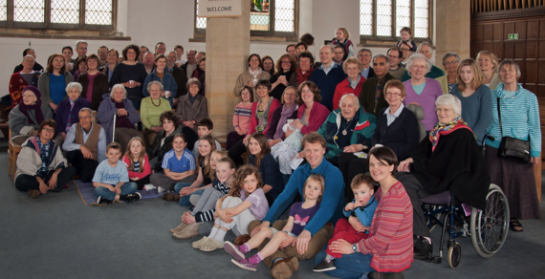

*How you can help*

* If you are not yet a regular giver to the Church, please pray about whether you could consider regular, planned giving.
* If you are an existing regular giver, please consider increasing your gift.
* If possible, please make your giving by Standing Order by completing the form and returning it to your bank. You can also give by envelopes.
* Take advantage of Gift Aid by signing the declaration form. This means that for every £1.00 you give to the church, we will receive £1.25

*Your Response*

Please bring the completed forms to church on our Commitment Sunday on 25th October.

(Or if this is not possible, please post or hand it into the parish office).

*Our Future*

We have a vision for growth of our congregations and our community outreach. What we require is faith, boldness and generosity in our giving according to our circumstances. I am certain that by God’s grace and our commitment we will have the resources to lay hold of these opportunities.

*Our Prayer*

Heavenly Father, thank you for the gift of life, love and

your Son, Jesus Christ. Help us to be generous in return, and support our Parish as it seeks to serve you and proclaim the Gospel afresh to each generation.

Dear Friends

Many people recognise the importance of St Anyone’s, Anytown and it is a real privilege to be called to serve in such a vibrant church at the heart of the community.

I am committed to helping our richly gifted church family revitalise the church, and strengthening our finances is the next step in our journey. The Parish Funding Programme offers the opportunity for those who currently give to review their individual commitment and for others to join them as a regular or one-off donation.

With your support, we will achieve our vision for our church and lay strong foundations for the future.

John Speech, Rector

*We would love you to prayerfully consider if you would be*

*willing to support the church through this appeal.*

*Where does the money come from?*

We receive no local or national government or diocesan support. Our parish relies upon the generous financial support from those who regularly attend church, and around 78% of our income comes through regular planned giving. As a charity, the church benefits from tax recovery available through Gift Aid.

**Income Budget for 2015**

Planned Regular Giving from our Congregation £60,000

Collections, donations, occasional gift aid envelopes £10,000

Tax Recovery - Gift Aid £13,000

Rents, Fees, Building Hire, Investment Income £12,000

*Our Financial Target for 2015*

To maintain and develop our existing ministry in line with our Vision and Mission statements, we will require a £19,000 (20%) increase in giving, yielding an additional £1,583.00 per month.

*How could this be achieved?*

At present there are 108 households giving regularly to the church.

If we could increase this to 120 and they were all able to contribute an additional…

**£2 p/w** (the cost of a takeaway coffee) = an increase in £13,440

**£4 p/w** (a pint of beer & packet of crisps) = an increase in £26,880

**£6 p/w** (a bottle of wine or weekly paper bill) = an increase in £40,320

*Our Vision*

To be a lively, loving church, that is valuable to our neighbours.

We aim to be a welcoming and inclusive church family, without walls to the community, spirit led, bible focused, gospel shared and Jesus centered.

*Our Mission*

* Create worship that is accessible to people of all ages and stages of faith, and to those who are searching or unsure.
* To create opportunities for outreach with children, youth, families and the elderly.
* Improve our facilities for church and community events by installing a kitchen and toilet.

*Your Giving*

Firstly a thank you – giving and gratitude go together. We give out of gratitude for what we receive from God. Also, we continue to be grateful for those, who, even in these difficult financial times, give regularly and sacrificially to support the work of God and this Parish.

*How much does it cost to run the Parish?*