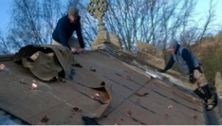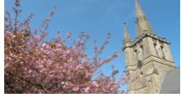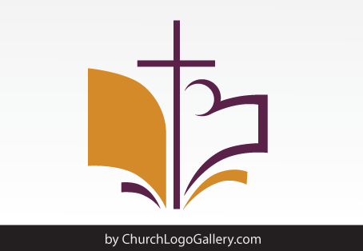

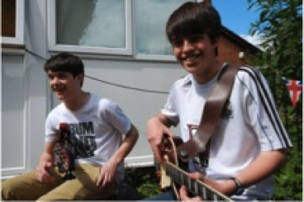

How you can make a

Lasting Gift to our Church

C

*A Lasting Gift*

We welcome all gifts in wills, however large or small, and we promise to use your gift to make a difference in our parish. We have been fortunate to receive such generous gifts in the past.

A generous legacy of £35,000 enabled us to hire a Youth and Families Worker.

The roof of St Peter’s was repaired thanks to a generous £10,000 legacy gift we received.

ST MICHAEL’S CHURCH

*Hawley*

ST MICHAEL’S CHURCH

*Hawley*

To request a free information pack, please visit www.churchlegacy.org.uk

You can also speak to the Treasurer or Stewardship Officer in confidence about gifts in wills. Please contact them via the Parish Office on 01542 837465 or admin@ourparish.org

*3 Simple Steps*

We encourage every adult

church member to:

1. Make a will and review it regularly.
2. Consider leaving a gift to our parish.
3. Request a free information pack.

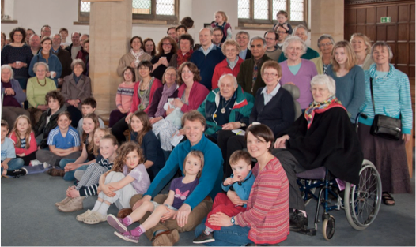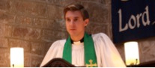

*Our Legacy Policy*

The policy of the PCC is to use gifts in wills to help fund significant development projects in the Parish. Since needs change over the years, we encourage church members to leave a gift in your will for the general purposes of the parish, rather than for a restricted purpose.

The PCC will discuss with executors the most appropriate use of the gift in the light of current projects and the donor’s known areas of interest in the church (e.g. children and youth, music, buildings).

**Suggested wording for your will:**

“ I give % of my residuary estate OR I give the sum of £ (pounds only) free of all taxes to the Parochial Church Council of the parish of St Michael’s Church, Hawley in the Diocese of Hereford for its general purposes, and I declare that the receipt of an officer of the Parochial Church Council shall be a sufficient discharge to my executors and trustees.”

**We strongly advise you see a solicitor when writing or amending your will.**

*Dear Friends*

It has always been a great encouragement whenever someone has left a gift in his or her will to our Church in the past.

It’s their testimony to the faithfulness, goodness and generosity of God and their thankfulness for the life of St Michael’s.

I want to encourage everyone in our church family, old and young to make a will, review it regularly, and consider the difference a gift in your will could make.

Thank you, **The Revd Paul Coates – Vicar**

LORD our God, all this abundance that we have provided for building you a temple for your Holy Name comes from your hand, and all of it belongs to you.”

(1 Chronicles 29)

*Your Parish, Your Gift*

Many people give regularly to the mission and ministry of the parish. We are stewards of everything we own, not just our income and gifts in wills are a natural part of that giving.

They are a valuable and lasting way to invigorate the life of St Michael’s and transform its future.

A gift in your will can be an expression of your gratitude and thanksgiving towards God, and can help keep your local church alive, and transform its future.

The PCC has written a Legacy Policy confirming that, however large or small, they will use your gift to make a real difference to our church.