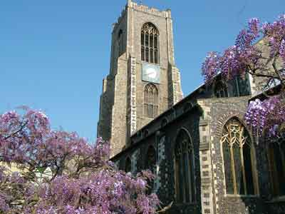
Name of Church, Parish

Name of Reverend
Address of Church
Contact Telephone and Email address

Dear First Name and Partner/Family name if appropriate

I have the pleasure of writing on behalf of the Parochial Church Council to invite you to a (Title of Launch Event e.g. Parish Supper) on (Date) at (Time) in (Venue).

This special event, for which there is no charge, will launch our new Promise Programme at St Anywhere’s, Anytown and will also provide the opportunity to say ‘Thank You’ for the support so generously given by so many people in the past.

This generous support has meant that, we as a church we have been able to:
Insert Paragraph outlining new projects, outreach work in the Community, work completed over past 5 – 10 years.

During the Title of the Launch Event we shall explain our Church’s plans for the future and how we plan to achieve development and growth in the years to come. We will also outline the resources required to meet the needs of the Church, however Nobody will be asked to make any decisions or donations at the Title of Launch Event, but just to think over what they have heard and consider how they can best help.

A supportive response can make a real difference to the ministry, which St Anywhere’s, Anytown can offer to our Community.

Please keep your enclosed invitation card as a reminder of the Title of Launch Event date, but it would be most helpful if you could return your Reply Card to Church or to the return address printed on the Reply Card by the RSVP date dd/mm/yyyy indicating whether or not you are able to attend.

We do hope that you will be able to attend and can promise each one of you a very warm welcome to what will be a most enjoyable occasion.

Yours sincerely,

Signature of Reverend and/or Funding Committee

Name of Reverend and/or Funding Committee

