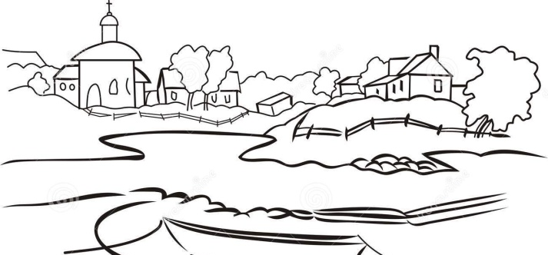

Community Audit Survey

This template outlines two sample surveys. The questions are open-ended, with space for survey-takers to write in people's responses. Remember to ask open questions, avoid leading questions and keep the document succinct. These are the ones that begin with What, Where, Why, When, How and Who? This encourages people to offer their own point of view.

You can adapt or add questions as appropriate. For example, you can list several possible initiatives that are being considered by the church and ask people which ones they think are best suited to their current needs. If you already have a building project in mind, you can change questions to ask: "Our church is considering doing ...... in this neighbourhood. Do you have any suggestions for how you'd like to see us do this?"

Community Survey non Applicable?
If you are an urban church, a community survey might not be the most effective way of engaging with the communities’ wants and needs. Most churches know their community context, and therefore will be able to adapt the consultation process to those that have been effective in the past. Here are a handful of other suggestions, in case they are helpful:
- Community meeting or event to inform people about the project
- A5 flyers or leaflets to hand out in the street
- Local stakeholders & charities who can help with project communications
- Targeting local services (hospital, job centre, schools, community centres)
- Public support from a local MP can raise the profile of the consultation
- Ask service users and groups to help collect feedback on the project
- Speak to local press, radio and social media
- Put up posters and flyers in local shops
- Place suggestion boxes around the church and local facilities
4

Community Survey Example 1

Hello, my name is .................................. and I'm with ......................... church.
We are about to embark on a large fundraising project to improve the facilities of our church for wider community use. We are conducting a survey of residents to help us learn more about our community needs and how we as a church can better provide for our community.
The information will be used by our church for the next phase of our Project Planning.

Name: ____________________________ Address: ___________________________

Length of time lived in this community: ____________________________

Age: 12-17 18-24 25 35-44 45-54 55-64 65-74 75+

Ages of children at home: _____________

Congregation members in your household (if any): ______________________

Local clubs, groups or organizations your family participates in:

__________________________________________________________________________

(for example: sports league, parent-teacher association, Boy/Girl Scouts)

1. What do you like best about this community? What makes this a good place to live?

_____________________________________________________________________

_____________________________________________________________________

_____________________________________________________________________

2. What three changes would you like to see that could make life better in this community?

1) _____________________________________________________________________

2) _____________________________________________________________________

3) _____________________________________________________________________

3. Our church is considering XXXX project. Do you have any suggestions for new usage?

_____________________________________________________________________

_____________________________________________________________________

4. Our church is considering XXXX project. How could this project benefit you / your family?

_____________________________________________________________________

_____________________________________________________________________

5. What role do you feel the church plays in our community?

_____________________________________________________________________

____________________________________________________________________

6. Is there any way we as a church can specifically pray for you?

_____________________________________________________________________

Thank you very much for your time and information!

Community Survey Example 2

Hello, my name is .................................. and I'm with ......................... church.
We are about to embark on a large fundraising project to improve the facilities of our church for wider community use. We are conducting a survey of residents to help us learn more about our community needs and how we as a church can better provide for our community. The information will be used by our church for the next phase of our Project Planning. Please highlight / circle as many options from the multiple choice below.

Please complete the following and a volunteer will collect
your response in 2 weeks time.

Name: ____________________________ Address: ___________________________

Length of time lived in this community: ____________________________

Age: 12-17 18-24 25 35-44 45-54 55-64 65-74 75+

Ages of children at home: _____________

Congregation members in your household (if any): ______________________

Local clubs, groups or organizations your family participates in:

__________________________________________________________________________

(for example: sports league, parent-teacher association, Boy/Girl Scouts)

1. What do you like about the town / village of _____________________?
- Transport
- Neighbours
- Local Services
- Community Spirit / Focus Point
- None / Don’t know
- Other (please specify)

2. What do you think are the important issues for the area?
- Crime / anti-social behaviour
- Facilities for Children / Teenagers
- Lack of Community Spirit / Community Focal Point
- Parking, Congestion and Traffic
- Problems associated with rental accommodation / students
- Lack of Community Space
- Care of Older People
- Loneliness for isolated members of the Community
- None / Don’t know
- Other (please specify)

3. What 3 changes would you like to see that could make life better in our community?

1) _____________________________________________________________________

2) _____________________________________________________________________

3) _____________________________________________________________________

4. Religious Belief: do you belong to a denomination?

- Christian
- Catholic
- Jewish
- Muslim
- Hindu
- Buddhist
- Other world faiths (please specify)

5. How would you define your religious beliefs?

- Religious – I believe in God and am religiously affiliated
- Believe in God but am not religious
- Agnostic – not sure whether I believe in God
- Atheist – no religious affiliation
- Prefer not to say

6. Have you or a family member attended any of these activities at Church?

- Sunday services / Christmas and Easter Services
- Christenings / Weddings or Funerals
- Youth Activities
- Children’s Activities e.g. Sunday School
- Parents and Toddlers Group
- Elderly and Infirm events e.g. care network, lunches
- Non-church activities e.g. blood donation, Taekwondo, Scouts
- None / Don’t know
- Other (please specify)

7. What other activities and services do you think the church might offer?

- A community focal point / a café with regular opening hours
- Debt counselling / advice
- Support services e.g. Alcoholics Anonymous
- Concerts / Art exhibitions
- Advocacy services / justice campaigns / conferences
- Food banks
- More youth and children’s activities / family support activities
- More support for old people, the infirm, the disabled
- A meeting place / hall for hire for non-Christian groups
- Other (please specify)

8. Comments from residents in favour of XXX project
_____________________________________________________________________
____________________________________________________________________
_____________________________________________________________________
____________________________________________________________________

9. Finally, any further comments
_____________________________________________________________________
____________________________________________________________________
_____________________________________________________________________
____________________________________________________________________
Thank you very much for your time and information!

